Assignment-1

Connect and disconnect with login Access

* What happens when you login a non-existent users or username?
  + Provide Screenshot and What you understand, explain in short brief?

-🡪

***Answer 1:*** It is throwing me an error as Sorry, that didn’t work. Please try again. As shown in the below screenshot:  
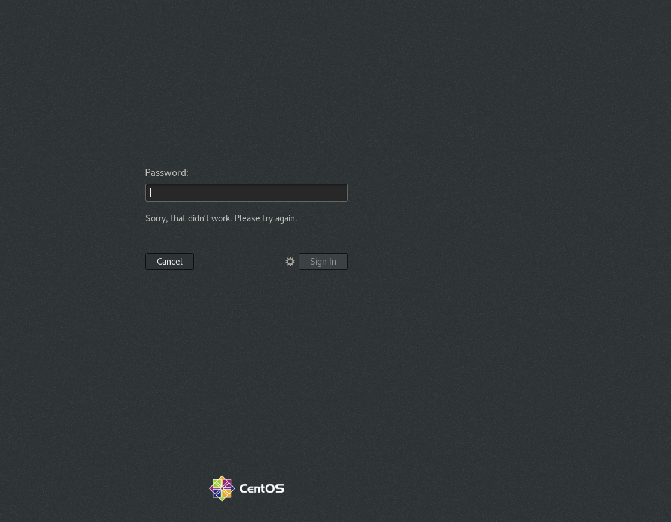

Assignment-2

Password changing

* Login into your account and then change password?
  + Change your password into **IneuR0n#42** and hit the **Enter** key
    - Explain what happen and give screenshot?

***Answer***: Password changed successfully.

* + Try again to change password but use like password ***1234*** or ***abcd***
    - Explain what happen and give screenshot?

***Answer***: Bad Password when typed “1234” and “abcd” as the password is shorter than 8 characters.

* + Try again to change password but now don’t use any password just hit **Enter** key
    - Explain what happen and give screenshot?

***Answer***: When we just hit enter, we get the output as ***No Password supplied.***

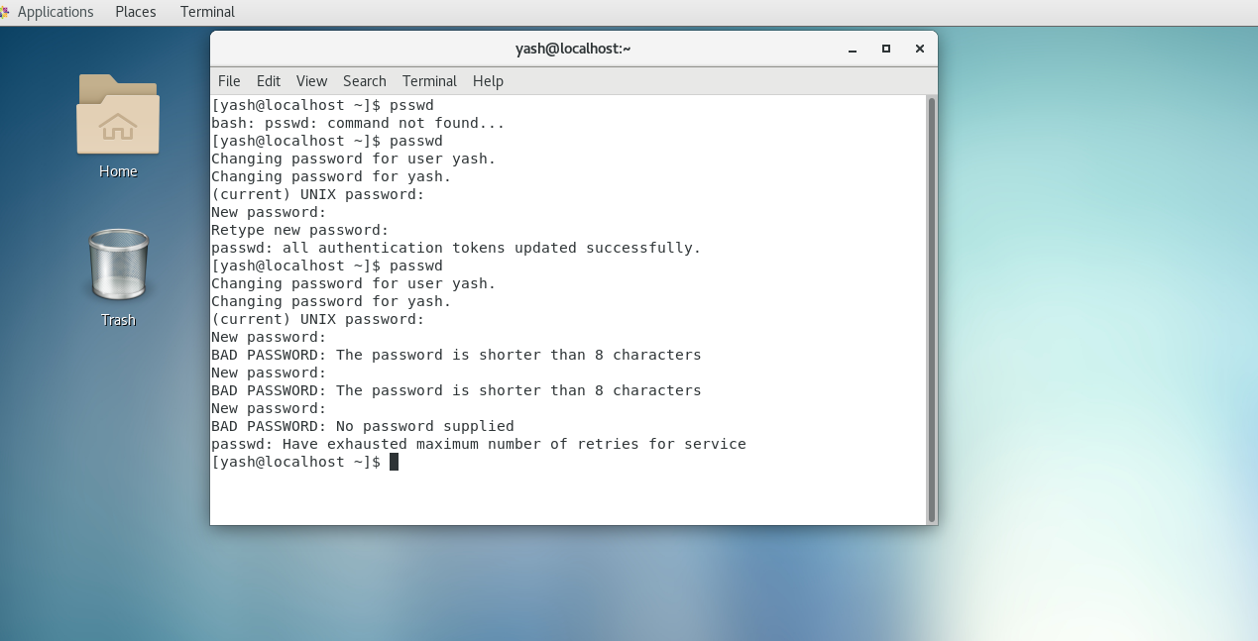

Assignment-3

Working with Directories

* Enter the command **cd /** and then **ls** and then hit **Enter** key
  + Take screenshot and explain what output we got?

***Answer***: cd / -> It is used to change current working directory and ls command will list all the directories and files in the current directory.

* Enter the command now **cd /home** and then hit **Enter** key
  + Do **ls,** provide screenshot and explain what is **/home** directory used for?

***Answer***: cd /home is used to navigate to the home directory and ls command is used to list the users in the home directory.

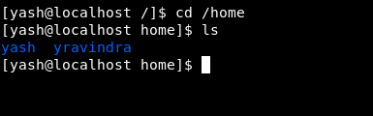

* Enter **cd ..** and hit **Enter** key [ *Note: here we have space after cd then use double dot*]
  + Check what happen and give screenshot?

***Answer***: cd .. is used to go one directory backwards or navigate to the previous directory.

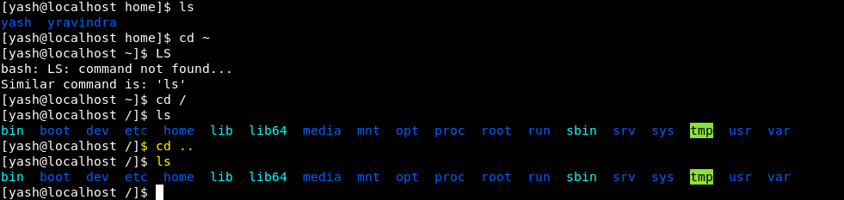

* Now enter **cd /var/www/html** and then type **cd** and hit **Enter** key
  + Explain what happen and give screenshot?

***Answer***: Getting output as No Such file or directory  
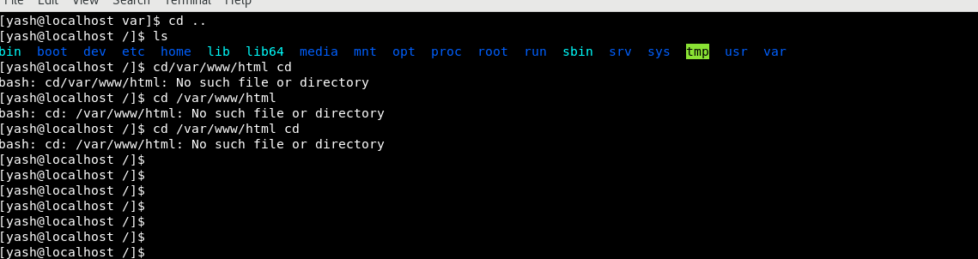

* Now type **cd /root** and then hit **Enter** key
  + Do **ls,** check any output we have on screen if yes then take screenshot?

***Answer1***: Permission Denied.  
  
***Answer2***: When logged into sudo user, below is the output

Assignment-4

Working with File Listing

* Go to **cd /etc** and type **ls**
  + Take screenshot and explain what files you have seeing?
  + Take screenshot and explain what different output you found compared cd to previous command you used?

***Answer***: The cd/etc consists of editable text configurations files which can be edited, and cd /root consists of config files.

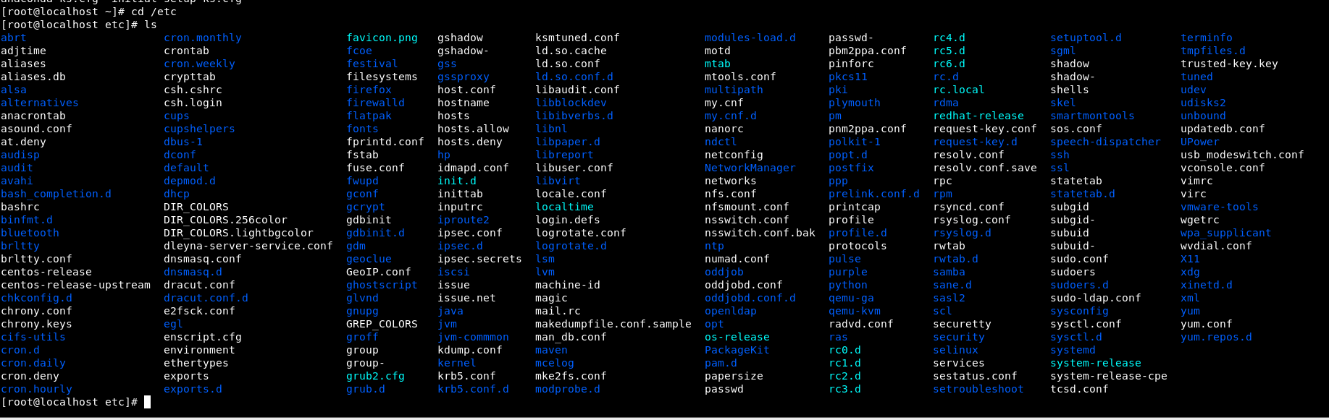

* Then type **ls -al** and hit **Enter** key
  + Take screenshot and explain what new file or directory you found?

***Answer***: ls -al will list all the file permissions, the number of links, owner name, owner group, file size, time of last modification, and the file or directory name.  
  
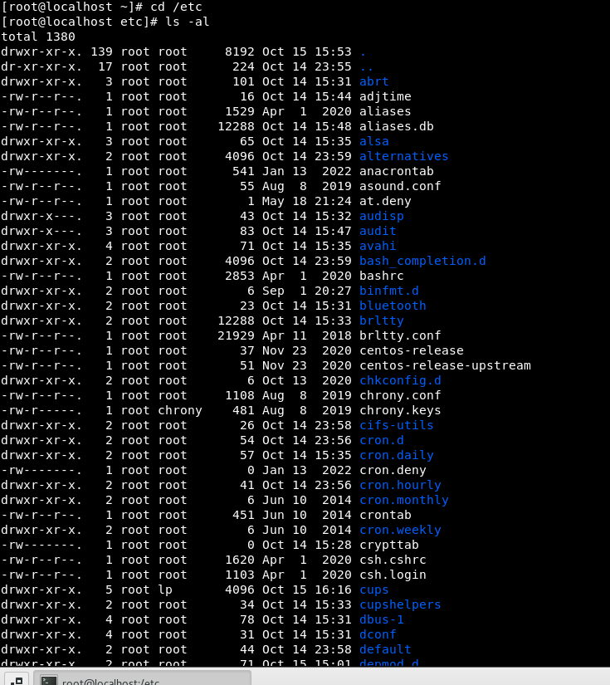

* Then use **ls -i** and hit **Enter** key
  + Now see what different output its shows and take screenshot?

***Answer***: This option will display the inode number beside each file or directory. Screenshot below

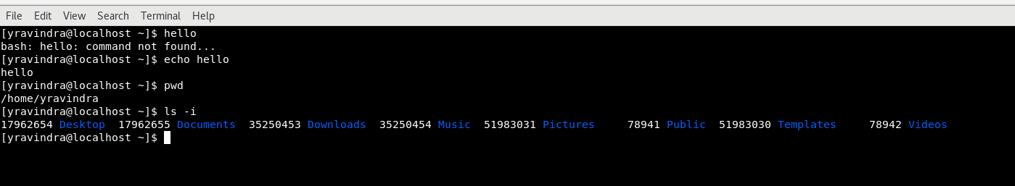

* Then use **ls –help** and see other options about **ls** command
  + Explore it and try with other attribute we can use with **ls** command

***Answer***: The correct Syntax should be ls --help and not ls single dash help i.e (ls –help)

Assignment-5

Know where you are and where you are working

*Here we use* ***pwd, cd and ls*** *as combine task to understand where you are working on terminal and how you can switch from one directory to another one.*

* Open terminal after restart the linux
  + Check which location you are working, type **pwd** and take screenshot

***Answer***: After reboot the Linux machine I typed pwd and seeing the below output and it determines that we are logged in as yravindra (current users home directory)

* Now use **cd /var** and hit **Enter** key
  + Do **ls,** and see what output comes, give screenshot?

***Answer***:

/var contains variable data files. This includes spool directories and files, administrative and logging data, and transient and temporary files. Some portions of /var are not shareable between different systems.

* Do explore other help options of each command to learn more other things we can do with these commands